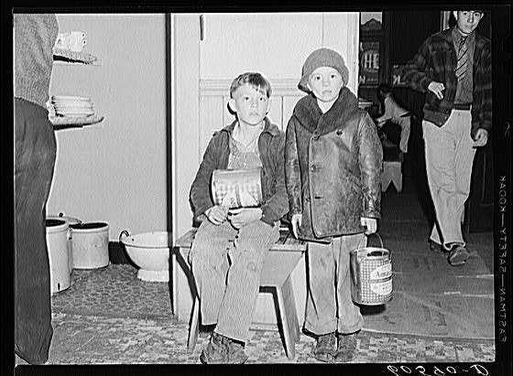

**Young boys waiting in kitchen of city mission for soup which is given out nightly. Dubuque, Iowa. April 1940. Photographer: John Vachon. For millions, soup kitchens offered the only food they would eat.**

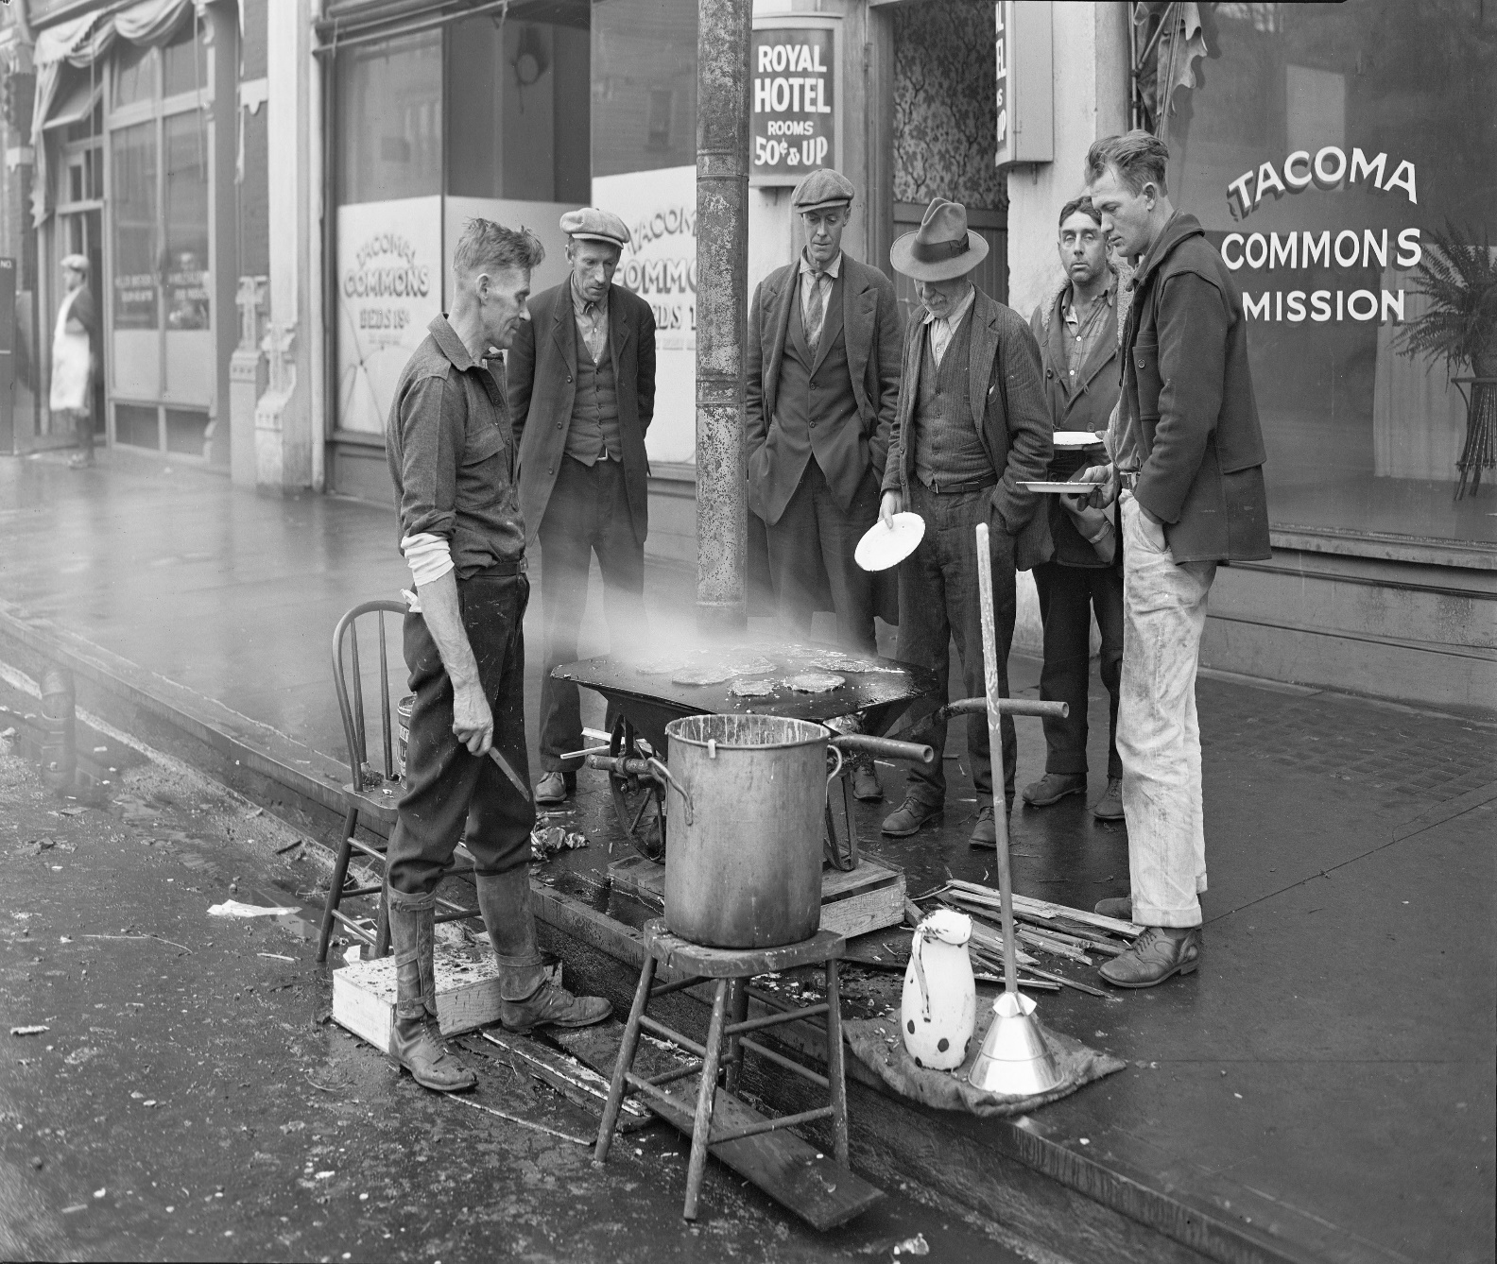

Men using a wheelbarrow as a makeshift stove are captured in Chapin Bowen's photo “Breakfast outside the Tacoma Commons Mission," taken in 1930;

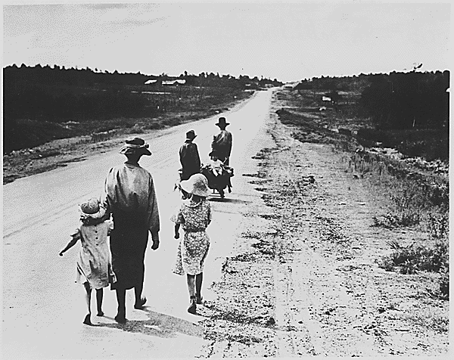

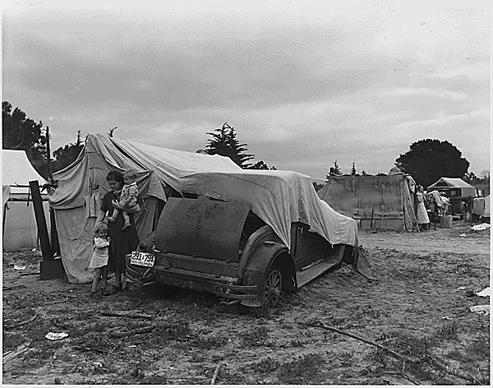

Migrant family looking for work in the pea fields of California. (Circa 1935)

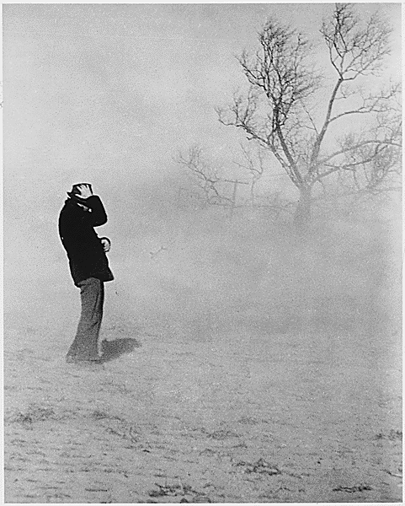

Dust Storms: In 1934 and 1936 drought and dust storms ravaged the great American plains and added to the New Deal's relief burden.

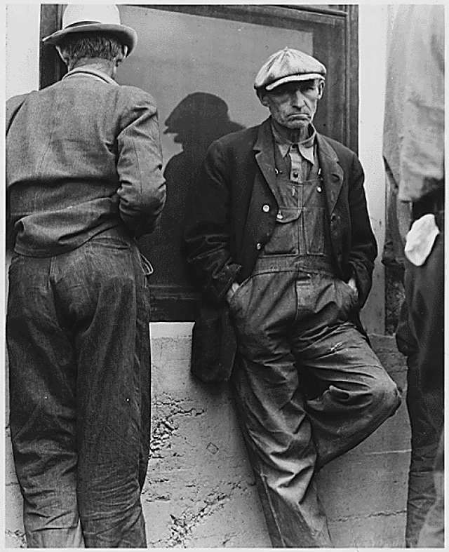

 Everywhere the unemployed stood in the streets, unable to find jobs and wondering how they could feed their families. (Circa 1935)

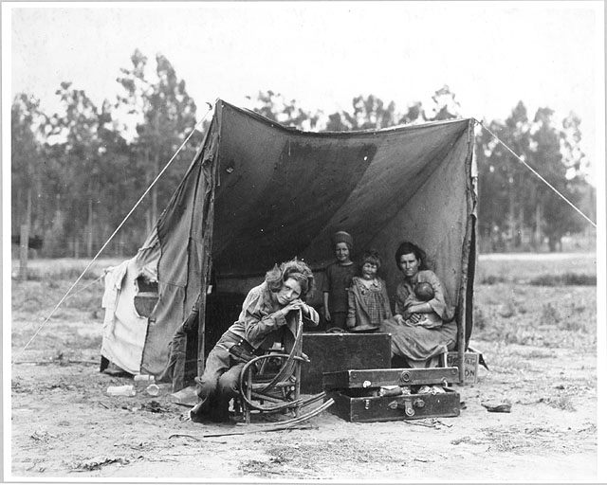

**The photograph that has become known as "Migrant Mother" is one of a series of photographs that Dorothea Lange made in February or March of 1936 in Nipomo, California.**