Lecture notes on “How far did the USA achieve prosperity in the 1920s?”

A 'how far' question ALWAYS indicates that there are two sides to the argument.

Between 1922 and 1929 the average Gross National Product of the USA increased 40%. GNP the market value of all the products and services produced in one year by labour and property supplied by the citizens of a country.

The Average income per head increased by 27%

Why Industry boomed [PAT GOT CASH]
a. Population growing rapidly increased demand for consumer goods.
b. Abundant raw materials – esp. coal, iron and oil – allowed cheap production
c. Tariffs – protected American industry from competition

d. Government – the government relaxed regulations and reduced taxes (this is called ‘laissez faire’)
e. Opportunities of New Technology (e.g. electrical goods, radio, film, nylon)
f. Techniques of production– Ford’s Assembly line method, and Frederick Taylor’s time and motion

g. Cycle of prosperity – increased prosperity increased prosperity.
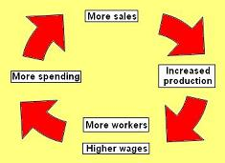
h. Advertising (e.g. billboards, radio commercials,)
i. Sales methods (e.g. commercial travellers, mail order, chain stores such as Woolworths)
j. Hire Purchase – instalments allowed people to buy now, pay later

2. Poverty and Depression
Not everyone shared in the prosperity, however, and there were glaring weaknesses in the American economy in the 1920s.
Particular problems included [FLOP CUTS]:

- Farming –
  - Machinery and overproduction led to rapidly falling prices (wheat prices fell from $183. a bushel in 1920 to 38 cents in 1929).
  - In 1929 average income of farmers was only 40% of the national average, and many farmers could not afford their mortgage;
  - in 1924 600,000 farmers went bankrupt.
  - Note also that rural areas did not have electricity, so most country-dwellers were excluded from the consumer boom.
- Low wage earners - e.g.
  - unskilled and casual workers, or the 2 million who were unemployed –
  - There were great inequalities of wealth; the top 5% of the population earned 33% of the income, while 60% of Americans earned less than $2000, and that 40% were below the poverty line (notably farmers/ Black Americans/ immigrants). Only 3% of semi-skilled works owned a car.
c. Old Industries - overproduction of coal (which was being replaced by oil and gas) led to mine closure and falling wages. In 1929 a coal miners wage was barely a third of the national average income. There were also problems in the textiles industry (where 'flapper' fashions were reducing the amount of cloth used to make clothes).
d. Poor Black Americans - 1 million black farm workers lost their jobs in the 1920s. Black workers in the towns in the north were the lowest paid; the only work they found available were low-paying, menial jobs. New York's black Harlem district was a severely overcrowded and segregated community, with more than 250,000 citizens crammed into an area 50 blocks long and eight blocks wide. Many of these people had to sleep in shifts, going to bed when others went off to work. ‘Rent parties’ were common on Saturday nights, to raise money to pay the landlord on Sunday.
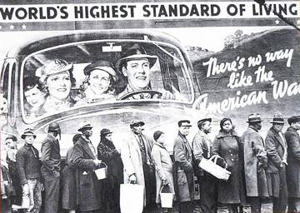
This photo is from the 1930s, but it sums up the position of Black people in the 1920s - they can SEE the prosperity, but they don't SHARE in it.

e. Cartels, trusts and monopolies - ‘fixed the market’ and tried to keep prices high and wages low.
f. Unemployment – new technology was throwing more and more people out of work; the number of unemployed stood at 2 million throughout 1920s.
g. Trade problems - high tariffs were causing other countries to retaliate, as well as reducing the purchasing power of those countries, which made it hard for American companies to export their products abroad. Farmers, who relied on exporting wheat, were especially hard-hit by this.
h. Stock Exchange – the biggest problem; Wall Street was 'over-heating. So great was over-confidence that people were even buying shares in imaginary companies. Many were buying shares ‘at the margin’ (a person could get a loan of up to 90% to buy shares) expecting to make enough profit to repay the loan when the shares were resold - brokers’ loans almost trebled 1926-9. All this threatened disaster if share prices everstopped rising.

